User Experience MacOS Intune – Corporate and BYOD

Automated Enrolment
- Power on the MacBook and select the preferred language and region.
- Connect to a Wi-Fi network.
- Follow the Setup Assistant prompts. When you reach the Remote Management screen, click Continue to enroll the device.
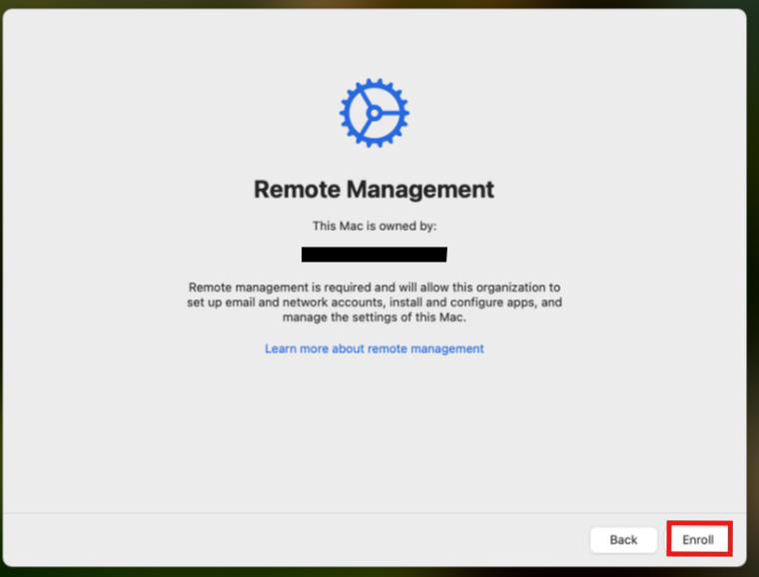
- Continue with enrollment and follow the on-screen instructions.
- When prompted, enable FileVault by clicking Continue.
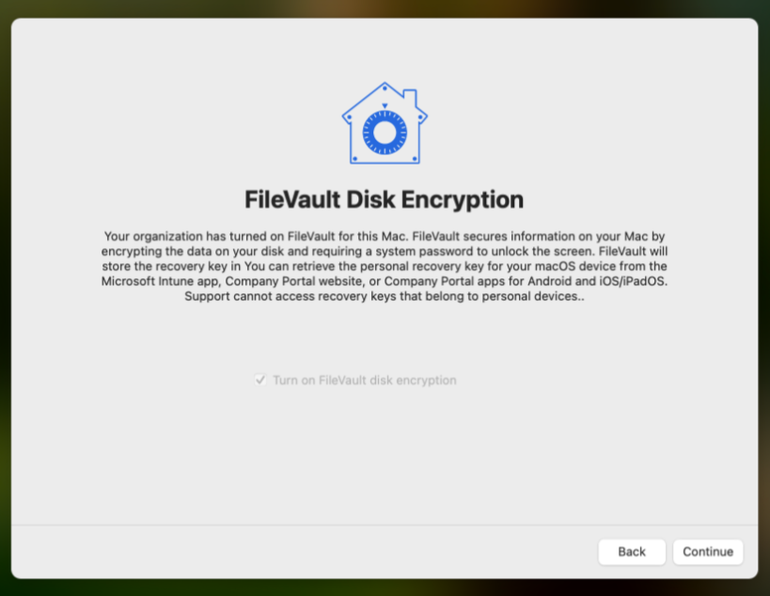
- Follow the prompts to create a user account, then continue through the remaining setup screens.
- After setup is complete, you will arrive at the macOS desktop.
- Allow required applications and policies to install automatically.
- Open Company Portal and complete any remaining actions if prompted.

Enrollment through Company Portal
- Download the Company Portal .pkg through the link https://go.microsoft.com/fwlink/?linkid=853070.
- Open the installer.
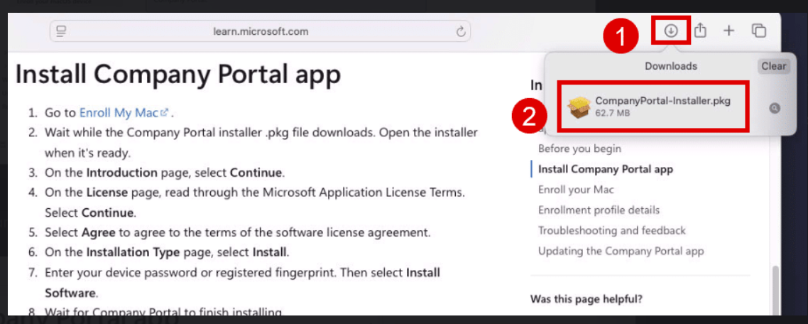
- Click Continue
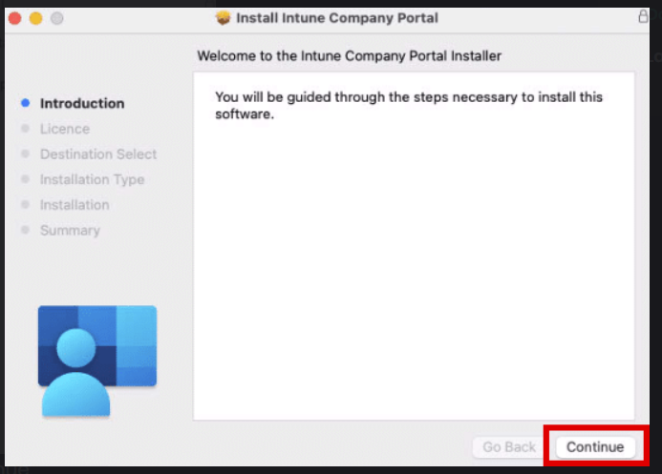
- Read through the License and click Continue.
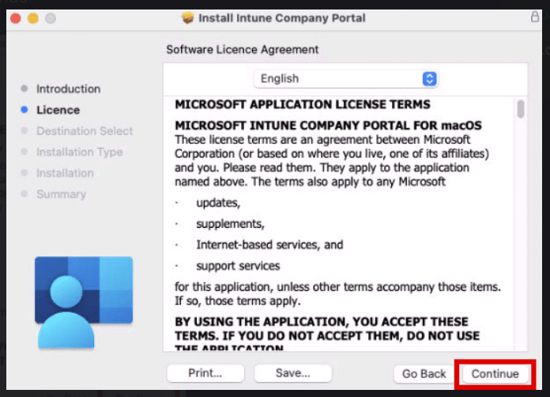
- Click Install
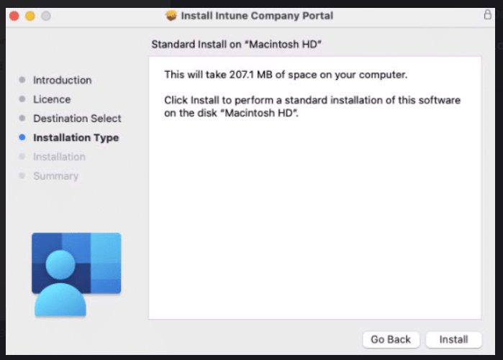
- Enter the password if prompted to proceed with the install.
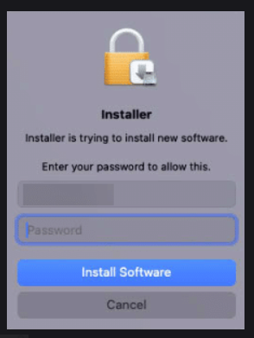
- Click on Close once the installation in completed.
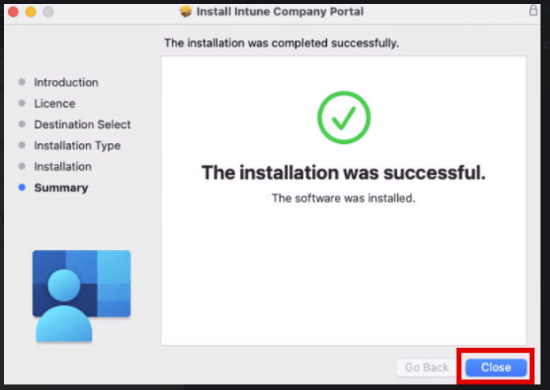
- Click on Move to Bin as the installer is no longer required.
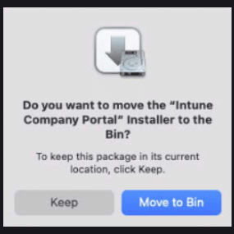
- Launch the Company Portal from Finder.
- Click Sign In.
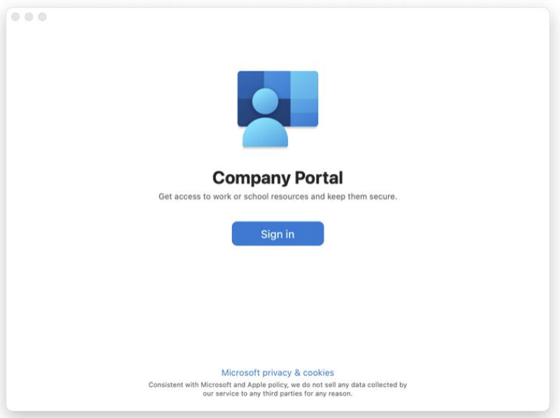
- Sign in with the ID and password.
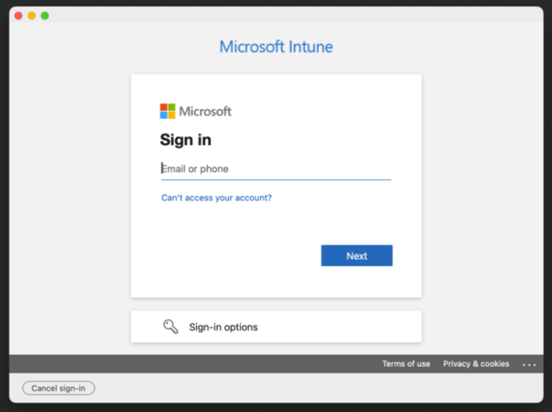
- Click Begin to start the enrollment process.
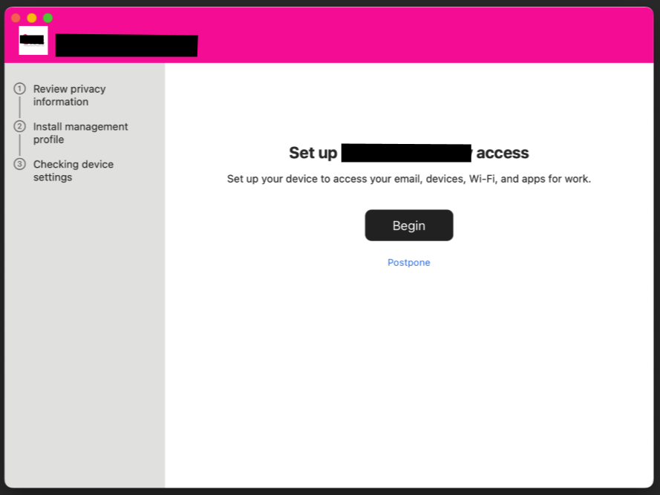
- Click Continue.
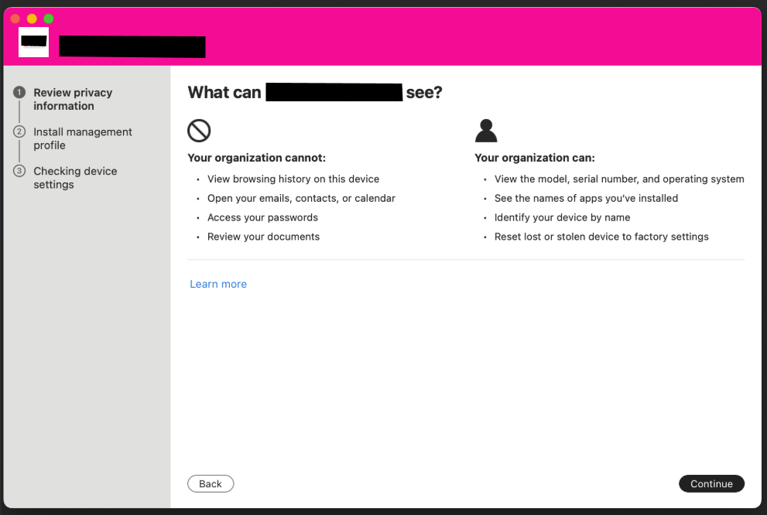
- Click on Download Profile
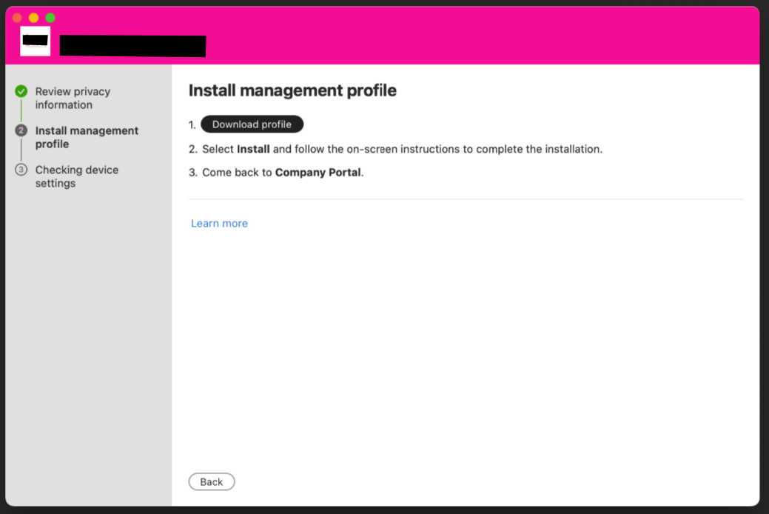
- In the Settings page, double click on the Management profile and click Install.
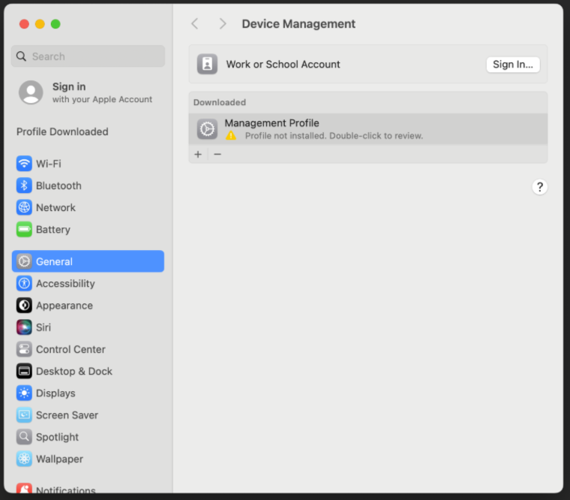
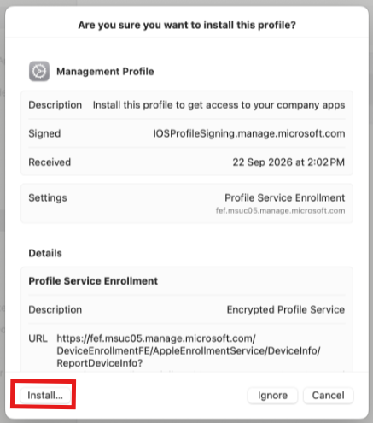
- Enter the password when prompted.
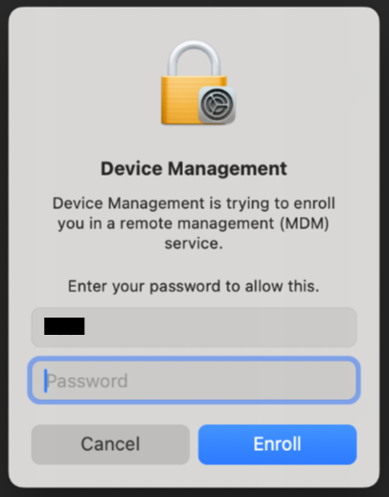
- Return to the Company Portal and wait for the page to go to the next step.
- Click on the Registration Required pop-up.
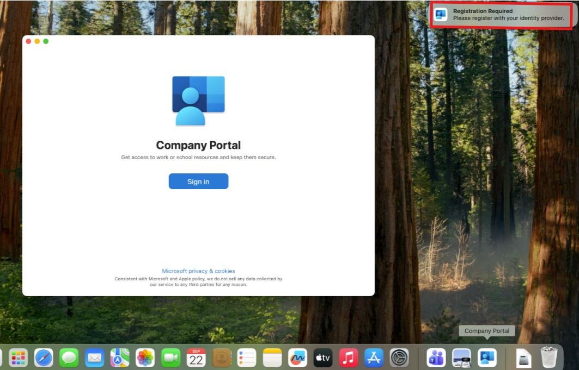

Note:
If unable to register account successfully, either sign-off user account and sign back in or restart the PC. Upon logging in, the prompt will appear again.
- Click Continue
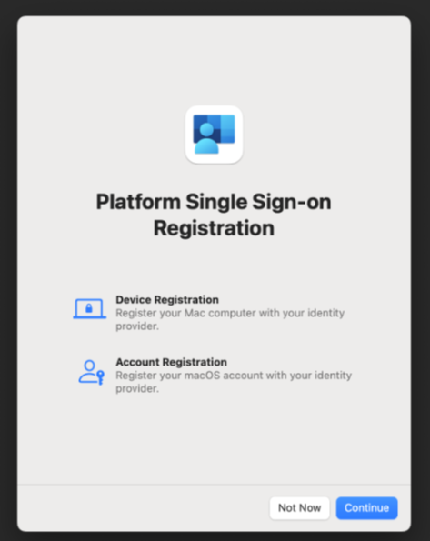
- Enter the Computer login password if prompted.
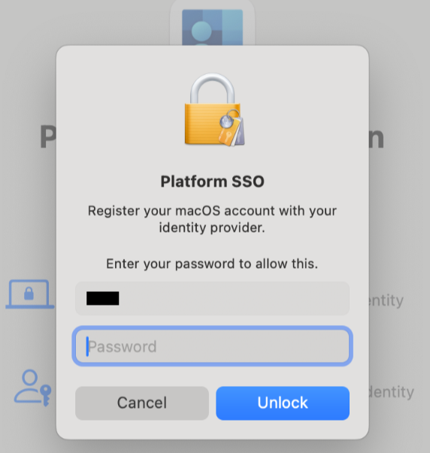
- Sign in with your account in the pop-up, and authenticate if required.
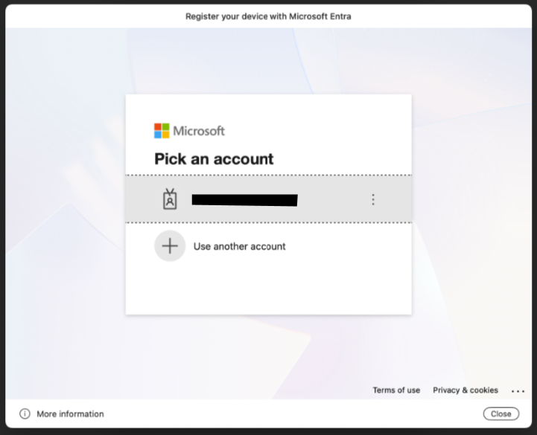
- Upon signing in, you will receive the following pop-up to enable Company Portal for Passwords and Passkeys. Click on Open System Settings.
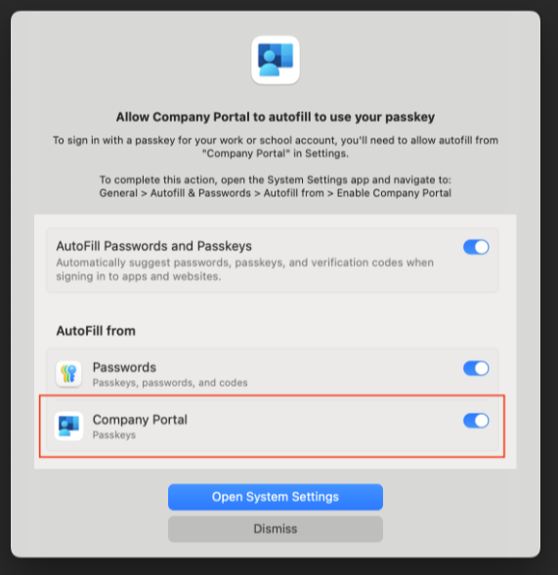
- Enable AutoFill Passwords and Passkeys and then Company Portal.
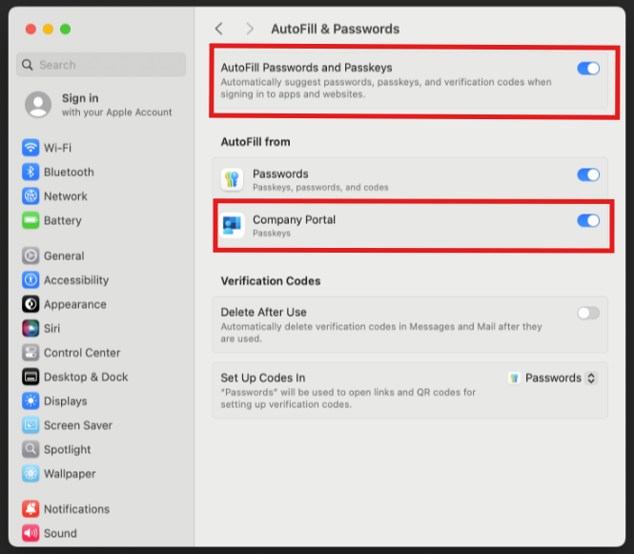
- Enable FileVault. Go to Settings – Privacy & Security – FileVault. Turn on FileVault, and enter the login password when prompted.
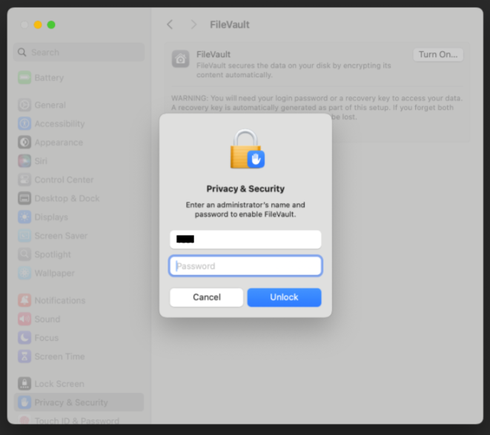
- Click Continue.
